FPS Framework Usage Guide
Thank you for installing the Untitled FPS Framework! This project aims to make life easier for those of us who can’t or simply don’t want to write all the code to make complicated things work.
This Framework includes a whole bunch of scripts designed to help you build an FPS game. Many of the core systems are built to work with each other, and this project is thus intended to be used as a collective – all of it or none of it.
At the time of writing, there are no custom inspectors for these scripts, which can make them kind of confusing. Each parameter will be detailed below.

Character Setup
The player character is arguably the most important part of the project. You’ll need to set this up properly to use any other part of the project.

Player Entity
The Player Entity script is what keeps the player alive (both figuratively and literally), managing the health and spawning of the player, as well as interacting and picking things up.
The inspector for the Player Entity might look confusing, but I promise it’s much easier to use than it may seem.
The fields up to the Health Modified Unity Event all belong to either Net Damageable or Net Entity, which the Net Player Entity inherits from, so we’ll cover those when we get to damageables.
- “Motor” – a reference to the Net Player Motor script on the player.
- “Buffer Manager” – a reference to the Net Buffer Manager script on the player. Required for client prediction and reconciliation.
- “Weapon Controller” – a reference to the Net Player Weapon Controller on the player.
- “Viewmodel Camera” – a reference to the player’s viewmodel camera, which should in the root of the player, not parented to anything else.
- “All Renderers” – an array populated with all the renderers on the character only, used for showing and hiding when the character is eliminated/gets revived.
- “Quick Revive Health Portion” – A 0-1 range of how much health the player spawns with when they are revived via a “Quick Revive,” issued via the Defibrillator script in the demo project.
- “Player Revive Item Prefab” – A reference to a prefab that is spawned in place of the player when they are eliminated. In the demo project, this is a trophy that can be picked up and used by friendly players to revive them.
- “Death Particle” – The particle system PARENTED TO THE PLAYER that is played when a player is eliminated.
- “Capsule” – A reference to the player’s Capsule Collider. Disabled and re-enabled on elimination/revive respectively.
- “Friendly Material/Enemy Material” – materials assigned to a player if they’re on your team or against you, applied to Material Override Renderers.
- “Interact Config” – A reference to a scriptable object containing config parameters for the interaction system.
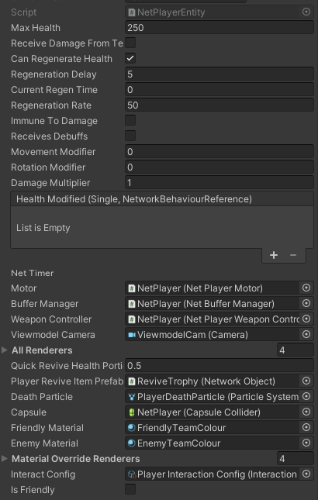

Player Motor
The Player Motor is the script that drives the character’s movement, rotation and a couple other things.
The inspector for the Player Motor looks like this (image below) and has a bunch of parameters extracted into scriptable objects for easy modification (and to help clogging the inspector)
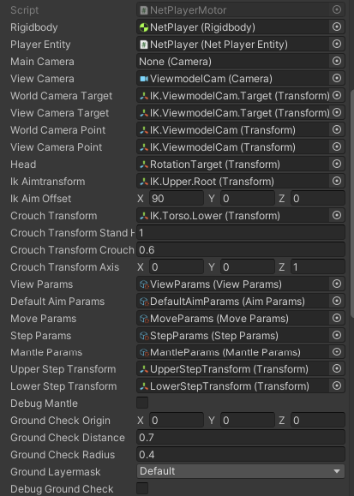

Weapon Setup
Weapons are super important in this project! How else would you shoot stuff without your guns?
There are loads of parameters even just on the Base Net Weapon script, which are also visible on everything that inherits from that script.

Ranged Weapons
Ranged weapons have a somewhat complex setup.

Melee Weapons
--- awaiting content ---

Throwable Weapons
--- awaiting content ---

